**HR Analytics Dashboard**

**Problem Statement:-**

**KPI’s Requirement**

The HR’s department is responsible for monitoring and managing various aspects of employee data to ensure the organisation maintains a healthy workforce. However, there is lack of clear performance indicators to track and analyse key HR metrics. Therefore, there is a need to design and implement a set fo KPI`s to address the following points:

**1.Employee Count:**

The HR department lacks visibility into the total number of employees, making it challenging to assess workforce size and plan for future growth of downsizing effectively

**2. Attrition Count:**

The organisation lacks a standardized method to track employee attrition, resulting in incomplete and unreliable data on the number of employee who have left the organisation.

**3. Attrition Rate:**

Without a clear measure of attrition rate, the organisation can not assess the overall turnover level or compare it with industry benchmarks, hindering the ability to gauge employee satisfaction and engagement.

**4. Active Employees:**

The organisation lacks a mechanism to differentiate between active and inactive employees, leading to difficulties in accurately assessing the current workforce’s productivity and capacity.

**5. Average Age:**

The HR department lacks visibility into the average age of employees, making it difficult to evaluate workforce demographics, succession , planning, and the organisation’s ability to attract and retain younger talent.

**Chart’s Requirement:**

**Attrition By Gender:**

The HR department faces challenges in understanding the attrition patterns based on gender, making it difficult to identify any gender-related disparities and implement targeted retention strategies.

**Department-wise Attrition:**

The HR department lacks visualisation to showcase attrition rates across different departments. This hinders their ability to identify departments with higher attrition rates and address any underlying issues or concerns effectively.

**Number of Employees by Age Group:**

The HR department requires visual representation to analyse the distribution of employees across various age groups. This helps in assessing workforce demographics, identifying any age-related gaps or imbalances, and implementing targeted HR policies or programs.

**Job Satisfaction Rating:**

The HR department lacks visualisation to represent job satisfaction ratings, hindering their ability to measure employee engagement and overall job satisfaction levels effectively.

**Education Field-wise Attrition:**

The HR department requires visual representation to analyse attrition rates based on education fields. This helps identify specific educational backgrounds that may be associated with higher attrition, enabling the organisation to tailor retention strategies accordingly.

**Attrition Rate by Gender for different Age Groups:**

The HR department lacks visualisation that display attrition rates based on gender and different age groups. This makes it challenging to identify any age and gender-related attrition trends, preventing the organisation from implementing targeted retention strategies for specific employee segments.

**Data:-** Glance of Raw data which we got:-

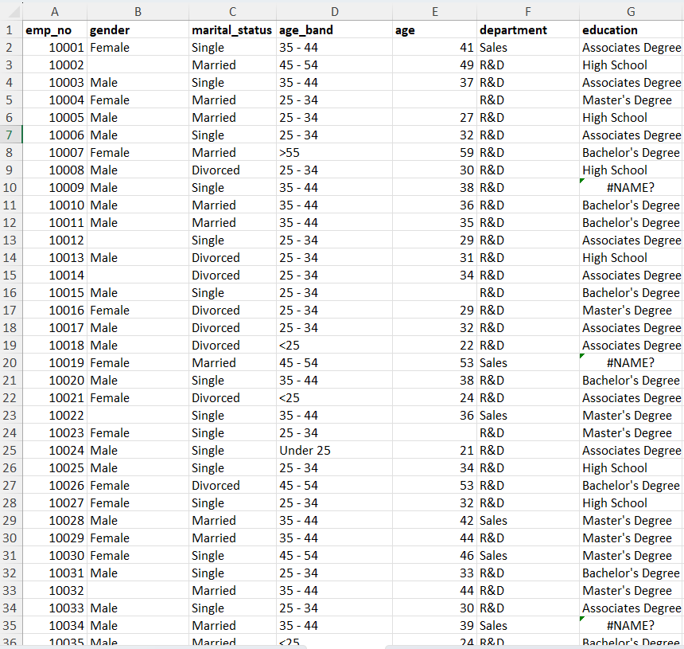

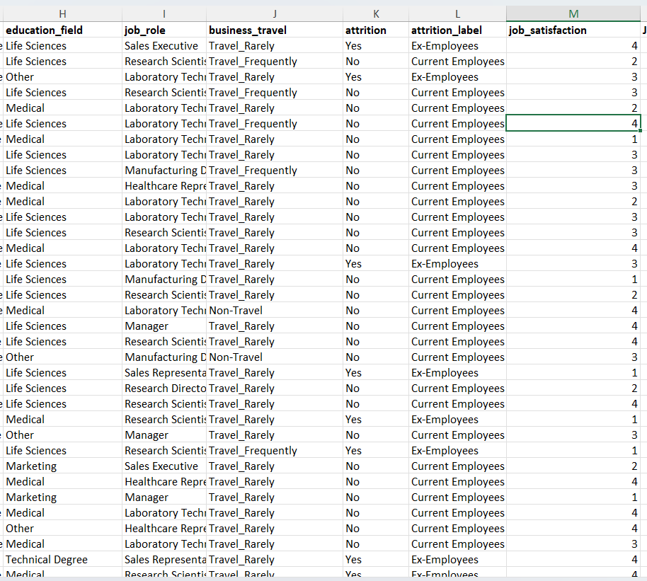

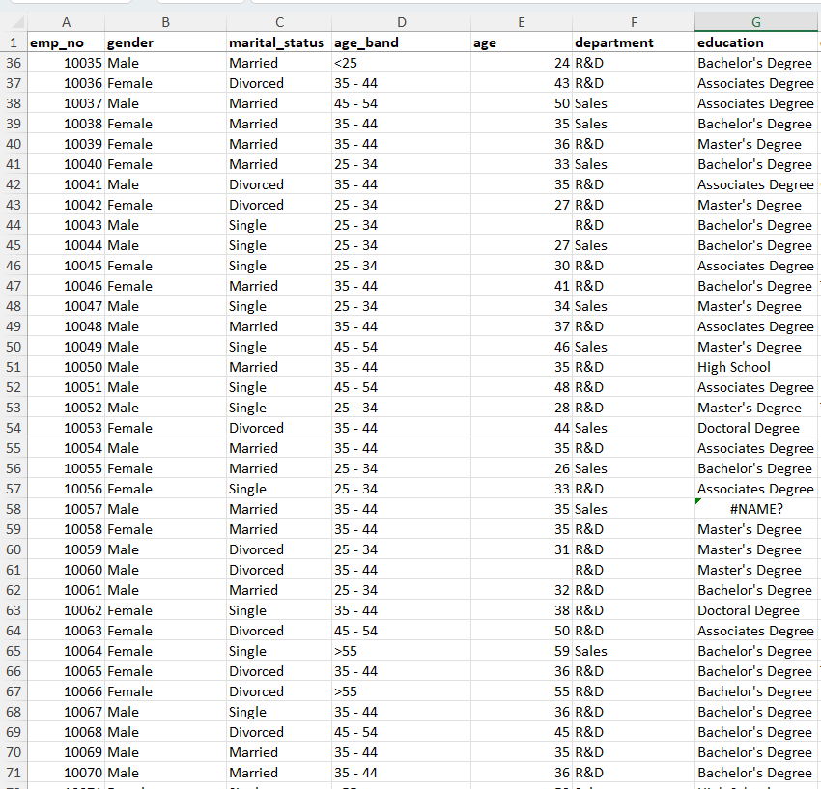

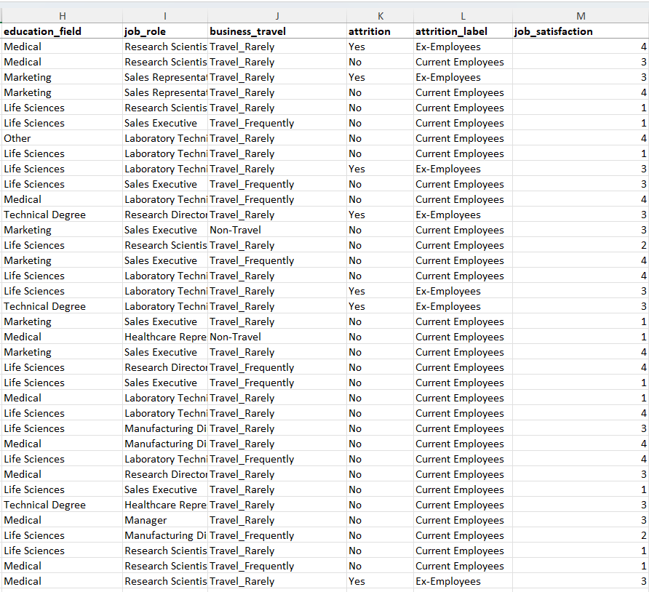

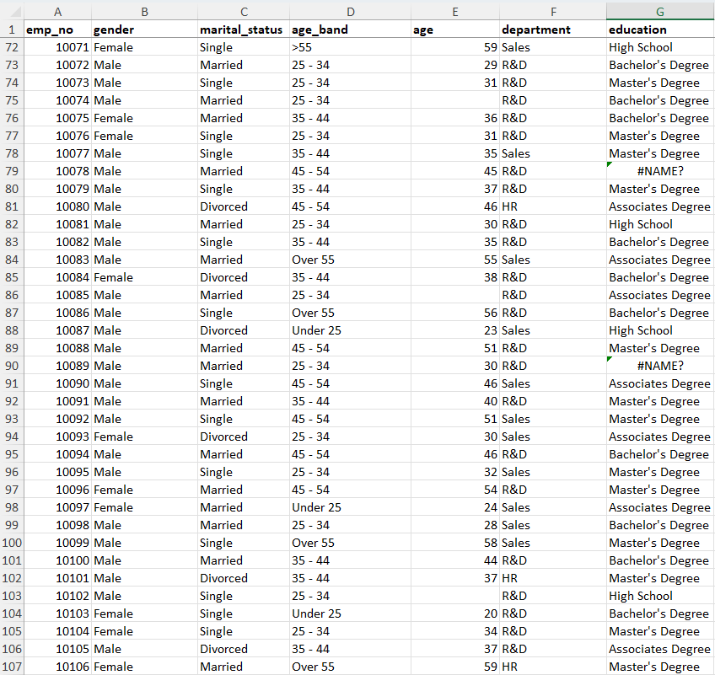

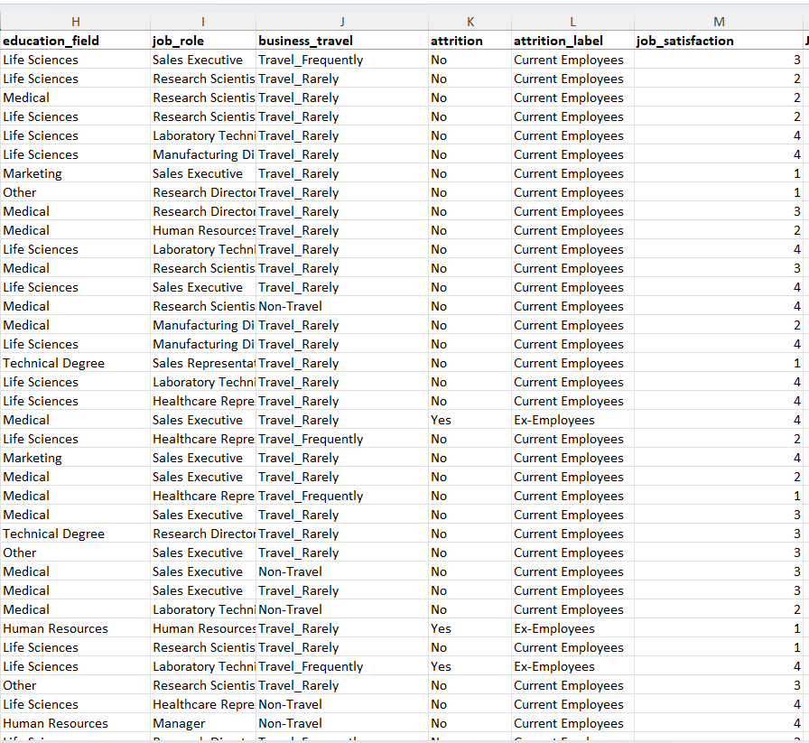

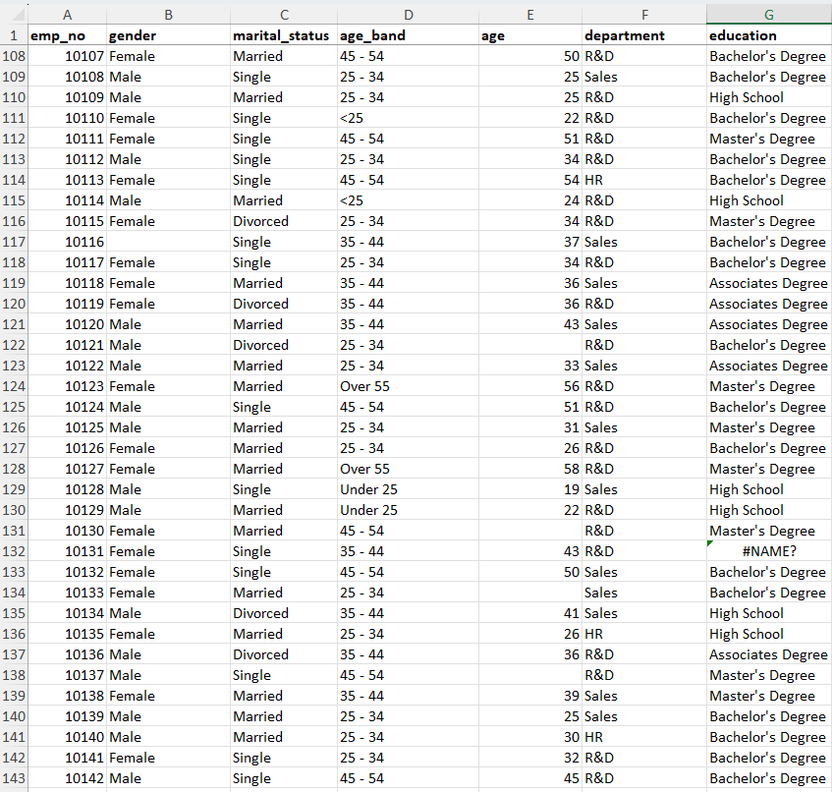

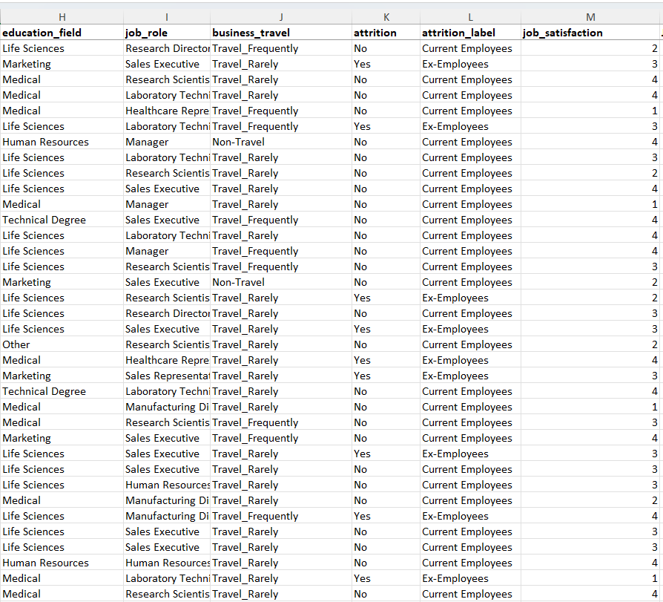

**Data Preprocessing and cleaning:-**Lets have glance of data preprocessing and data cleaning

On observing data and our requirements we selected these columns for cleaning and preprocessing:-

**Gender:-** Some empty cells are there . We impute them with highest frequency in gender column.

Value Imputed:- Highest frequency in gender column :- ♂Male

**Formula used: =IF(C5<>"",C5,IF(MAX(COUNTIF($C$2:$C$1471,"Female"),COUNTIF($C$2:$C$1471,"Male"))=COUNTIF($C$2:$C$1471,"Female"),"Female","Male"))**

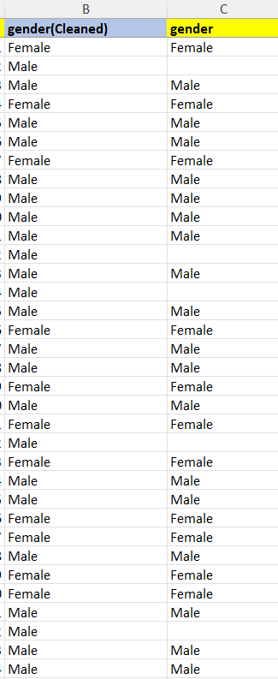

**Age_band:-** Greater then and smaller then symbol is used which is not fit for presentation needs and some values are Under 25 and some <25 , Over 55 and >55.

Replace <25 with Under 25 and >55 with Over 55

**Formula Used:-** Use simply find and replace option at column age_band.

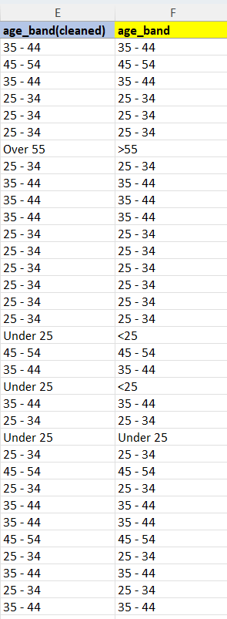

**Age:-** Some values are missing in age column . To reduce **data loss ,**  we will do imputation of average age , where age value is empty.

Value Imputed : -36

**Formula Used:- =IF(H3<>"",H3,MEDIAN($H$2:$H$1417))**

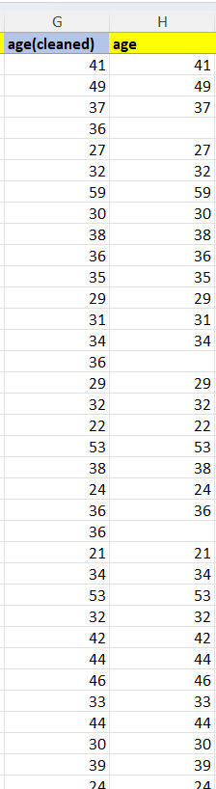

**Education:-** Got some null values in education column . Fill it with highest frequency value in that education column.

First change null values as empty cell (semi cleaned)

Then impute them with highest frequency value(cleaned)

Value Imputed:- Bachelor’s Degree

**Formula Used:-**

For semi cleaned:- **=IFERROR(L3,"")**

For total cleaned: - We use **VBA code**  to impute it .

First we make different sheet “**edu_sheet**”in which we paste semi-cleaned education column at column A . and after imputation we copy that imputed column and paste it in data processing and cleaning sheet/tab.

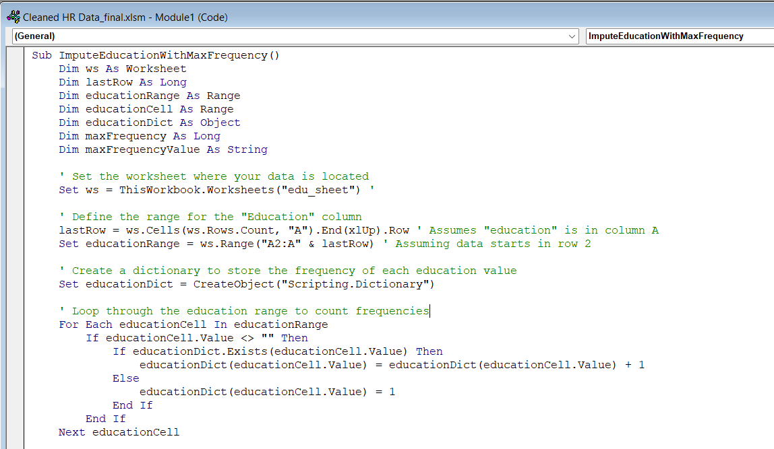

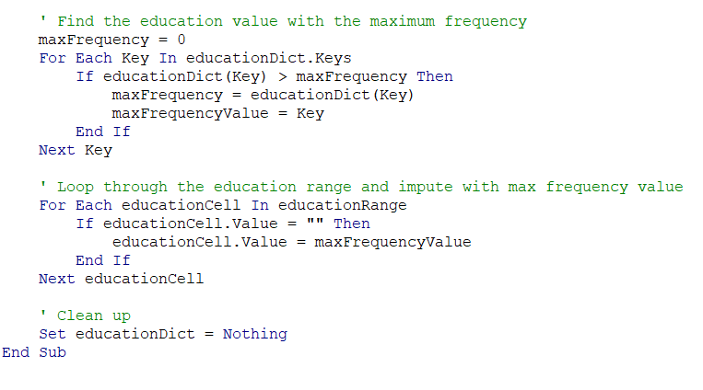

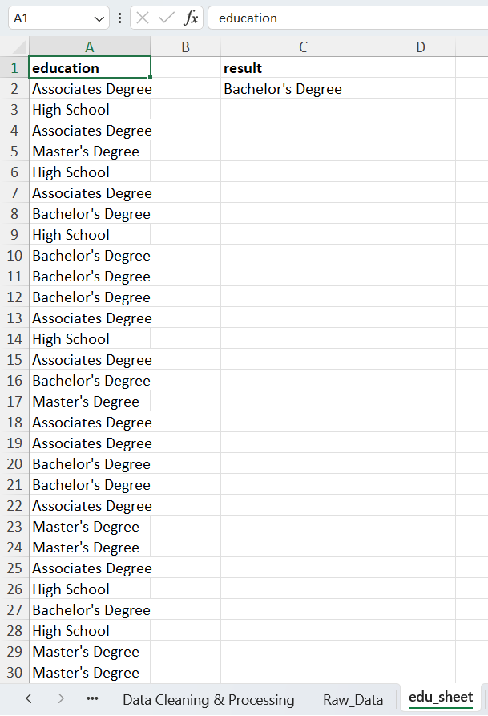

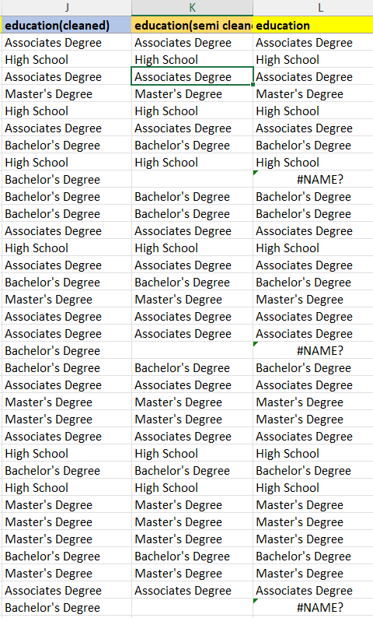

**Column Addition:-**

**Employee_count:-** This column is added to count the no. of employees

**Formula Used:- =IF(A2<>"",1,0)**

**Active Employee:-** This column is added to count active employee , assigning 1 corresponding to “Yes” at attrition and 0 corresponding to “NO”

**Formula Used:- =IF(P2= "Yes",0,1) (here P2 corresponds to attrition column)**

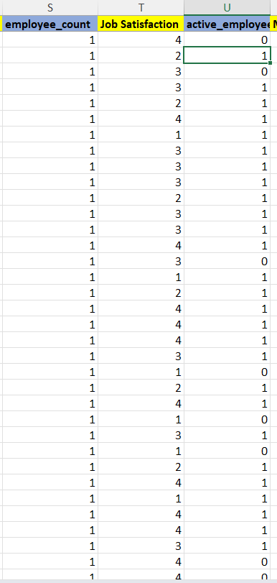

**Summary of Data Processing and Cleaning**

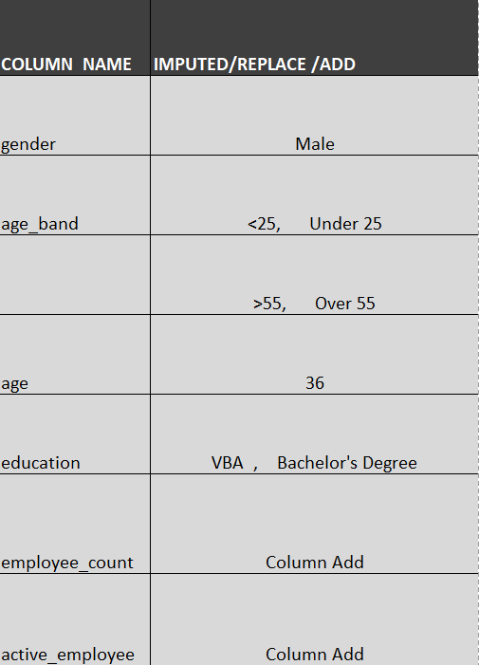

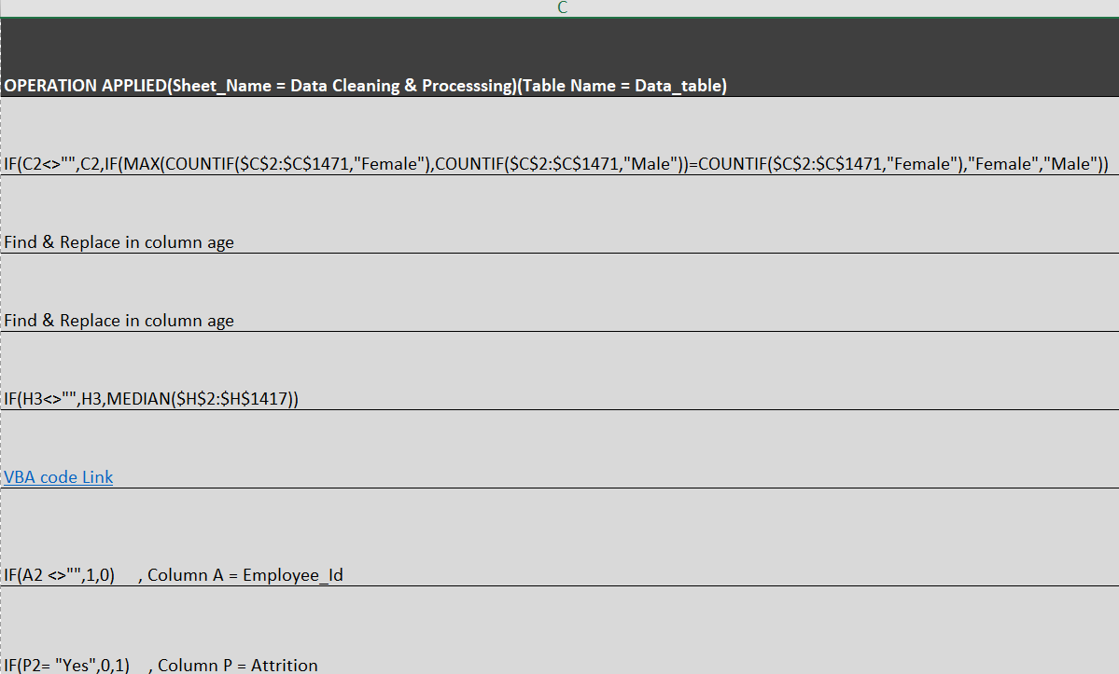

**Final Cleaned Data**

Lets have glance over final cleaned Data:-

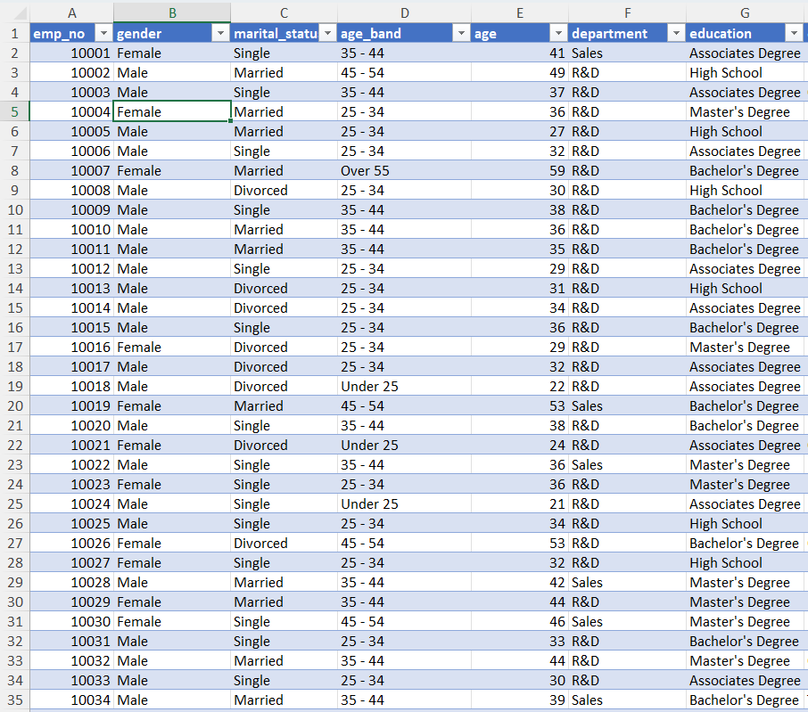

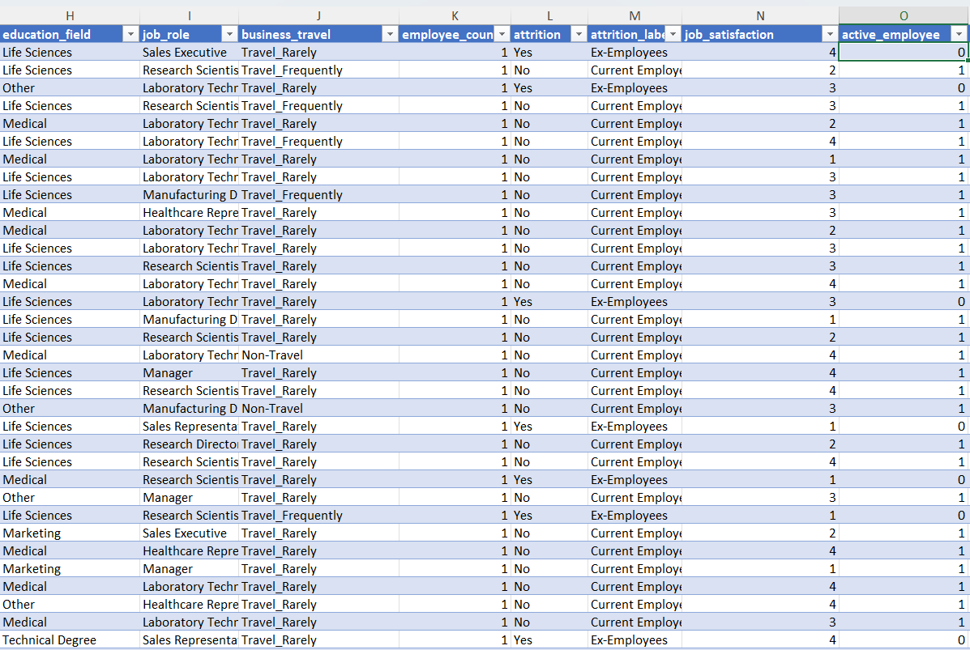

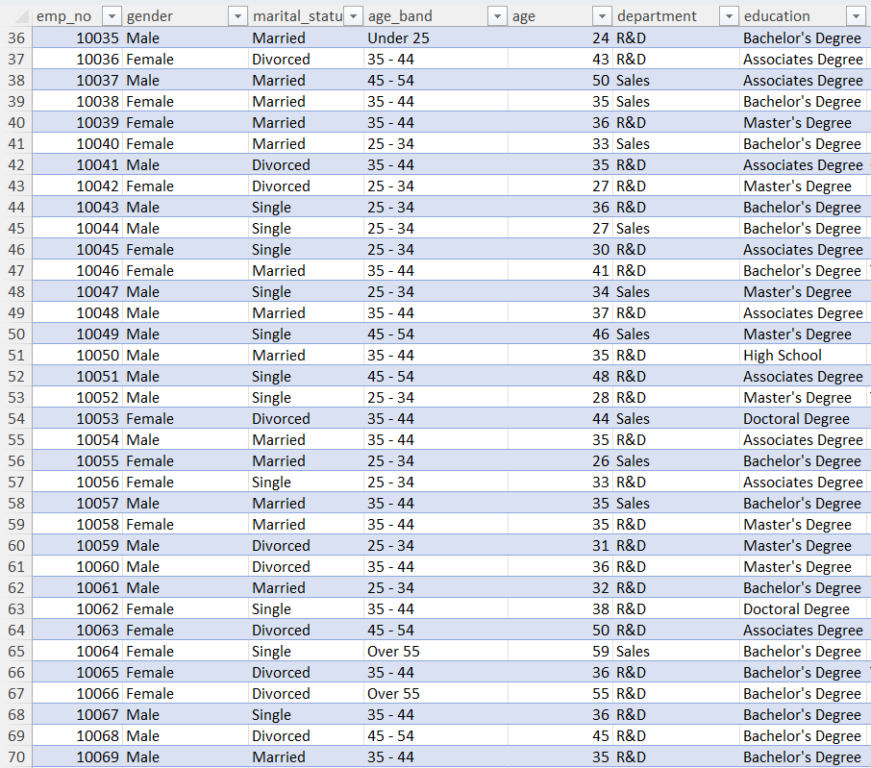

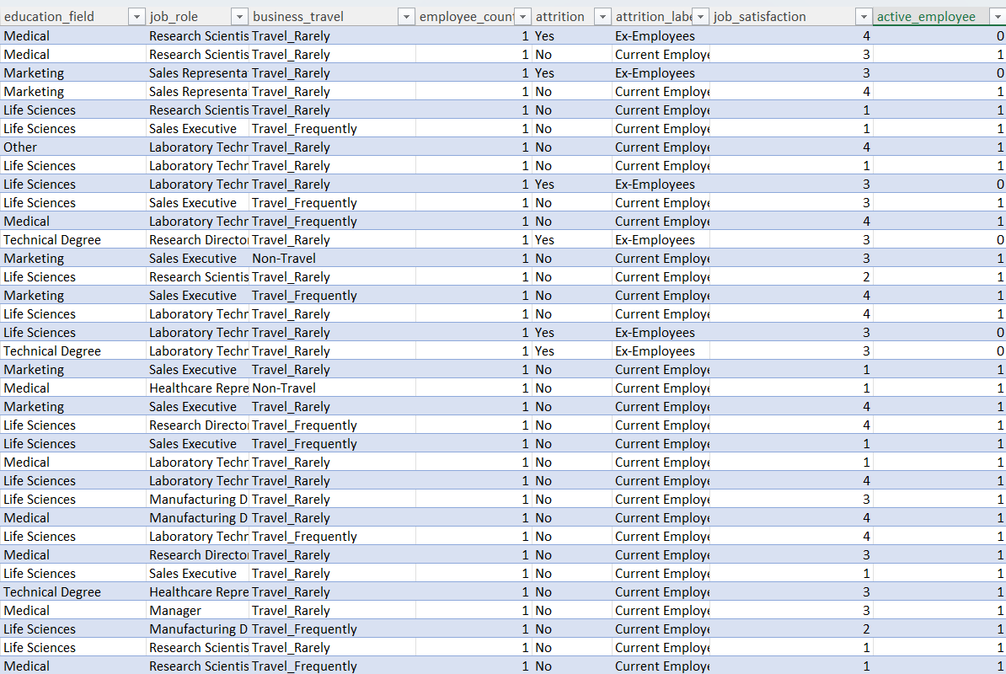

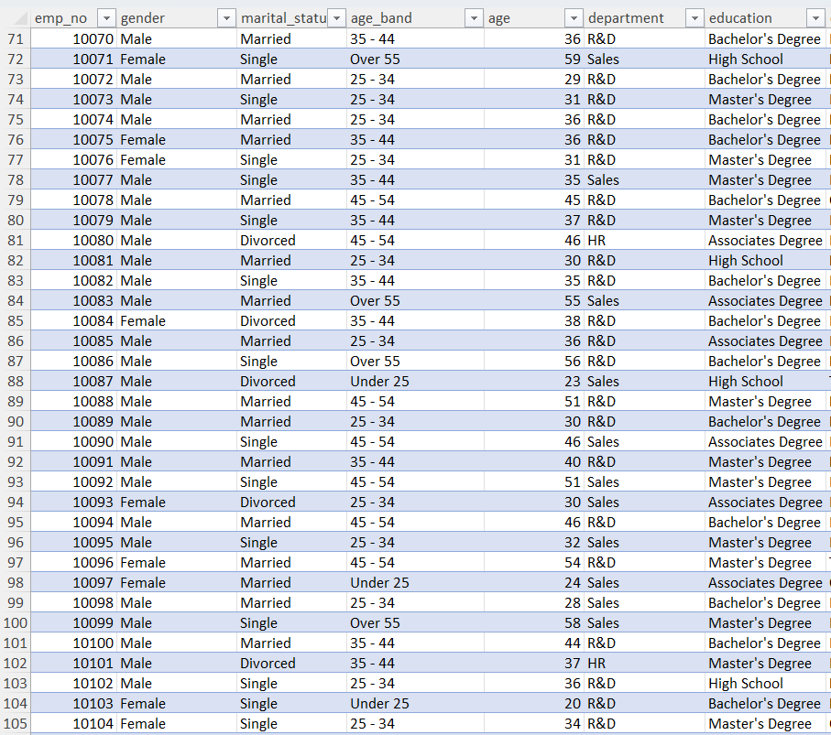

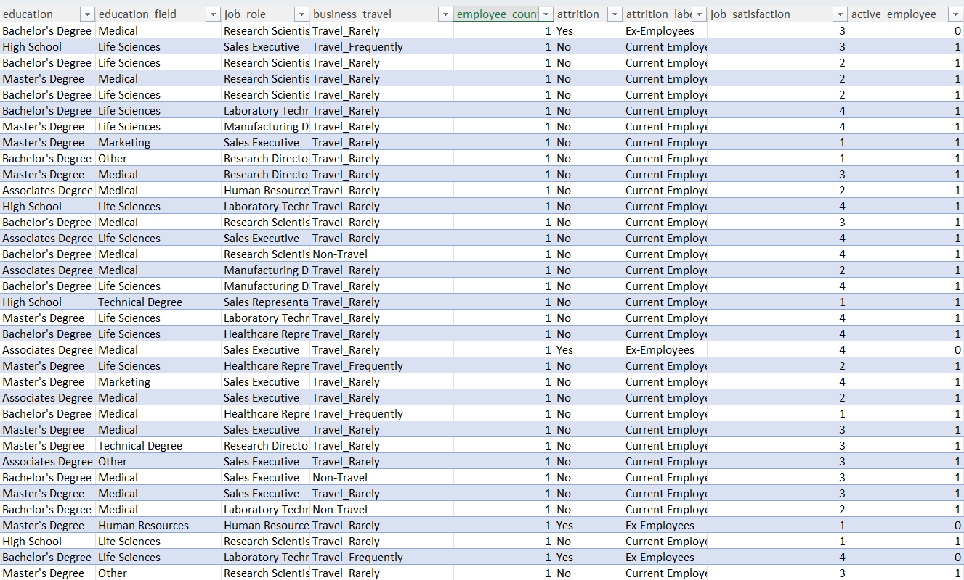

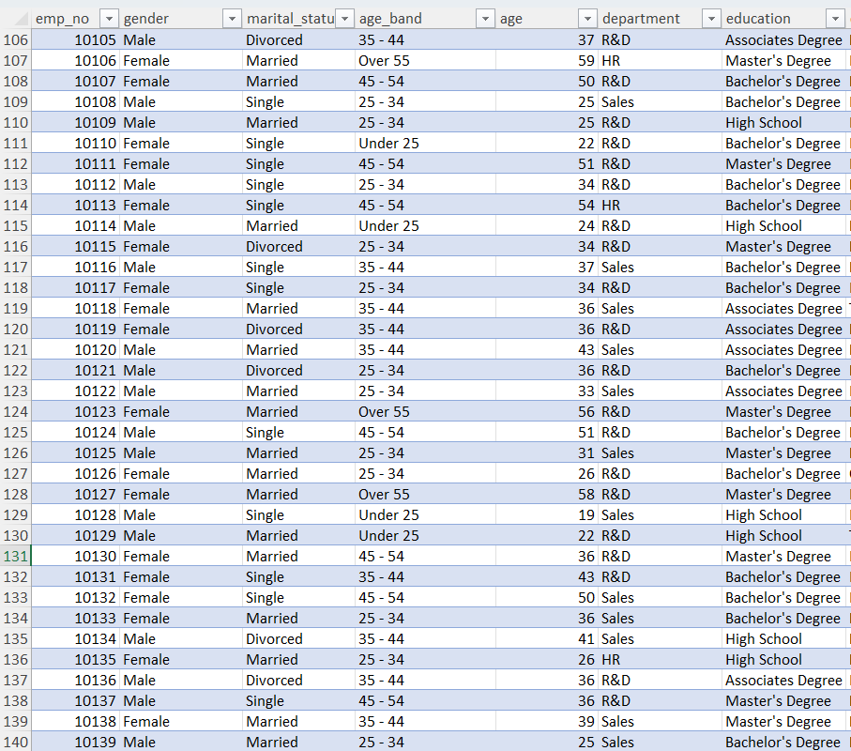

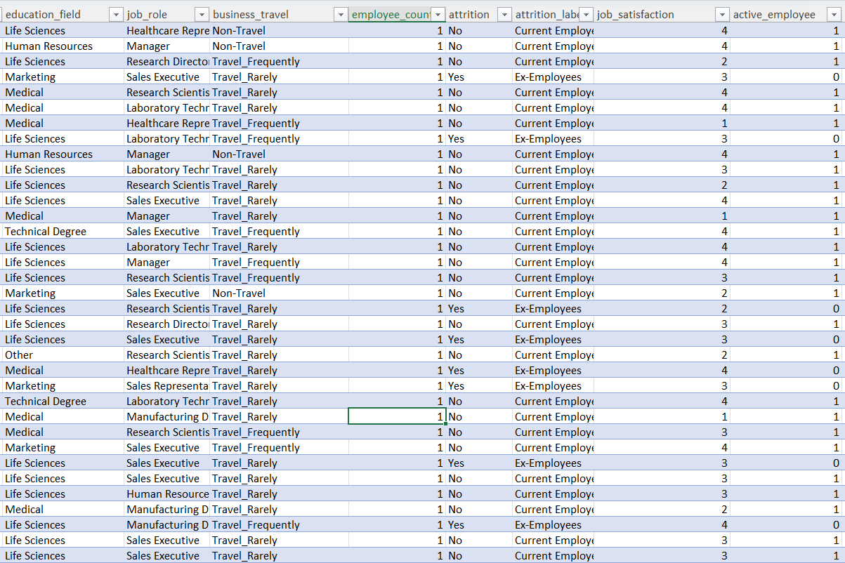

**Size of data(cleaned) = 1471 X 39**

**Dashboards:-**

We will create dashboard using 3 different software:-

1. Tableau
2. Power BI
3. Excel

We will also do sql check on Tableau and Power BI dashboard.

**Tableau Dashboard:-**

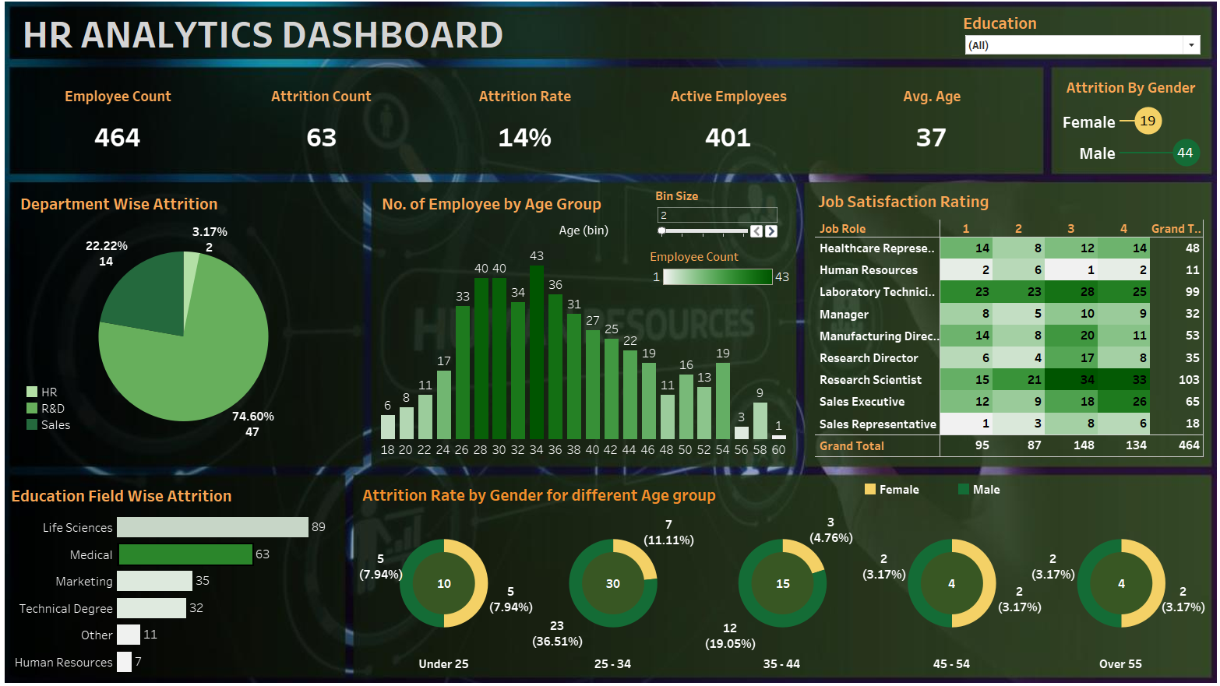

**Tableau Dashboard**

**Dashboard Summary:-** This Dashboard contain following features:

**KPIs:**

* **Employee Count:-** Total Number of employees in the organisation.
* **Attrition Count:-**  The number of employees who have left the organisation.
* **Attrition Rate:-** The percentage of employees who have left in a given period.
* **Active Employees:-** The number of employees currently employed.
* **Average Age:-** The average age of employees in the organisation.

**Charts:**

* **Attrition By Gender:-** A lolly pop(bar) chart showing attrition count by gender.
* **Department -wise Attrition:-** A pie chart displaying attrition count by department.
* **Number of Employees by Age Group:-** A histogram showing distribution of employees by age groups.
* **Job satisfaction rating:-**  A guage chart displaying job satisfaction ratings.
* **Education Field-wise attrition:-** A bar chart showing attrition count by education field.
* **Attrition Rate by Gender by Different Age groups:-** Series of Doughnut charts displaying attrition rates by gender and different age groups.

**Filters:**

**Education filter:-** Allow user to select particular education i.e. Bachelor’s Degree etc.

Glance of Tableau sheets which is used to make tableau dashboard:-

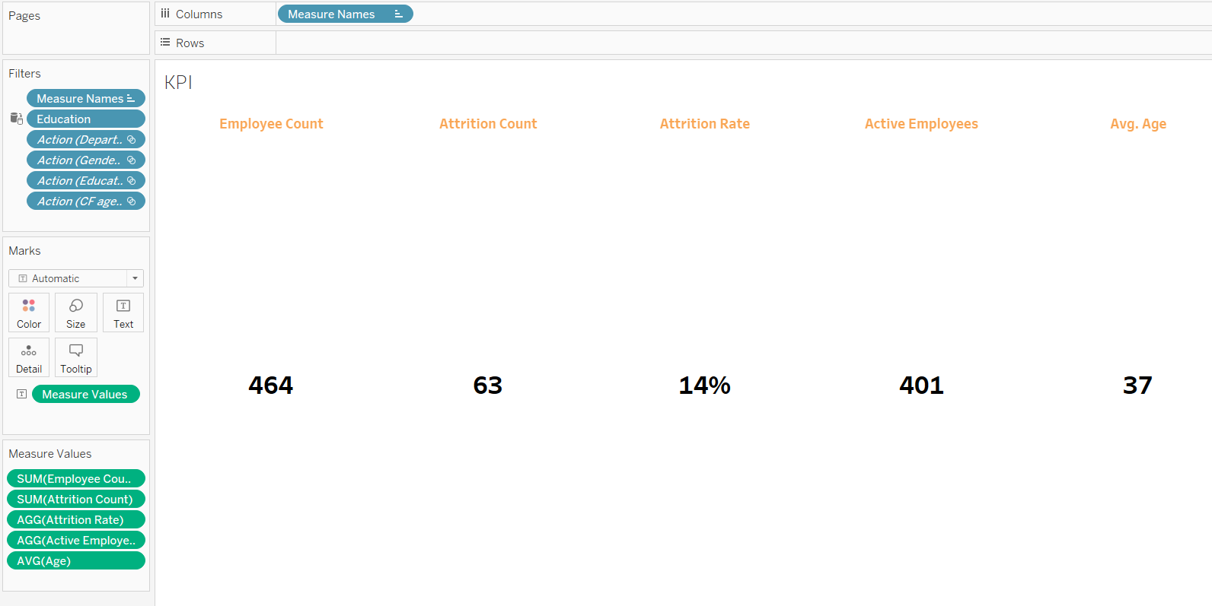

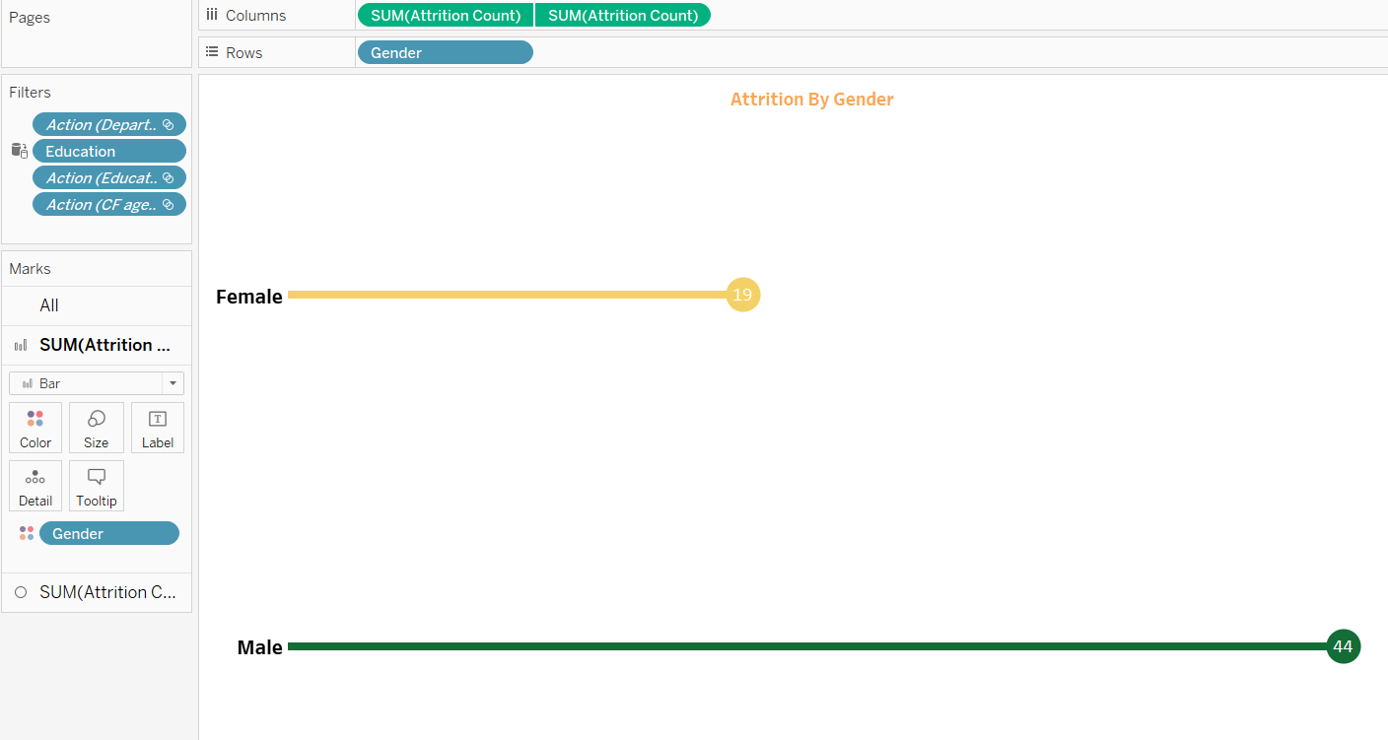

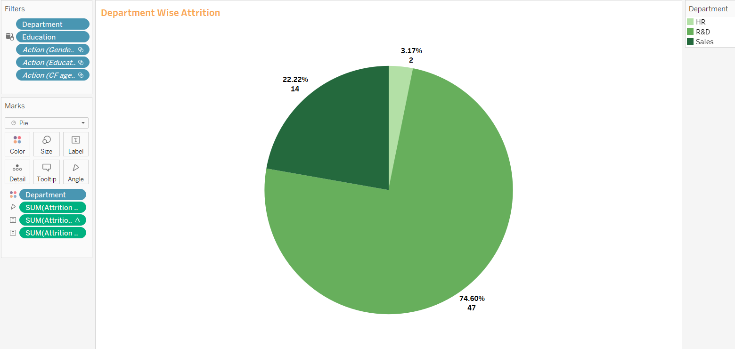

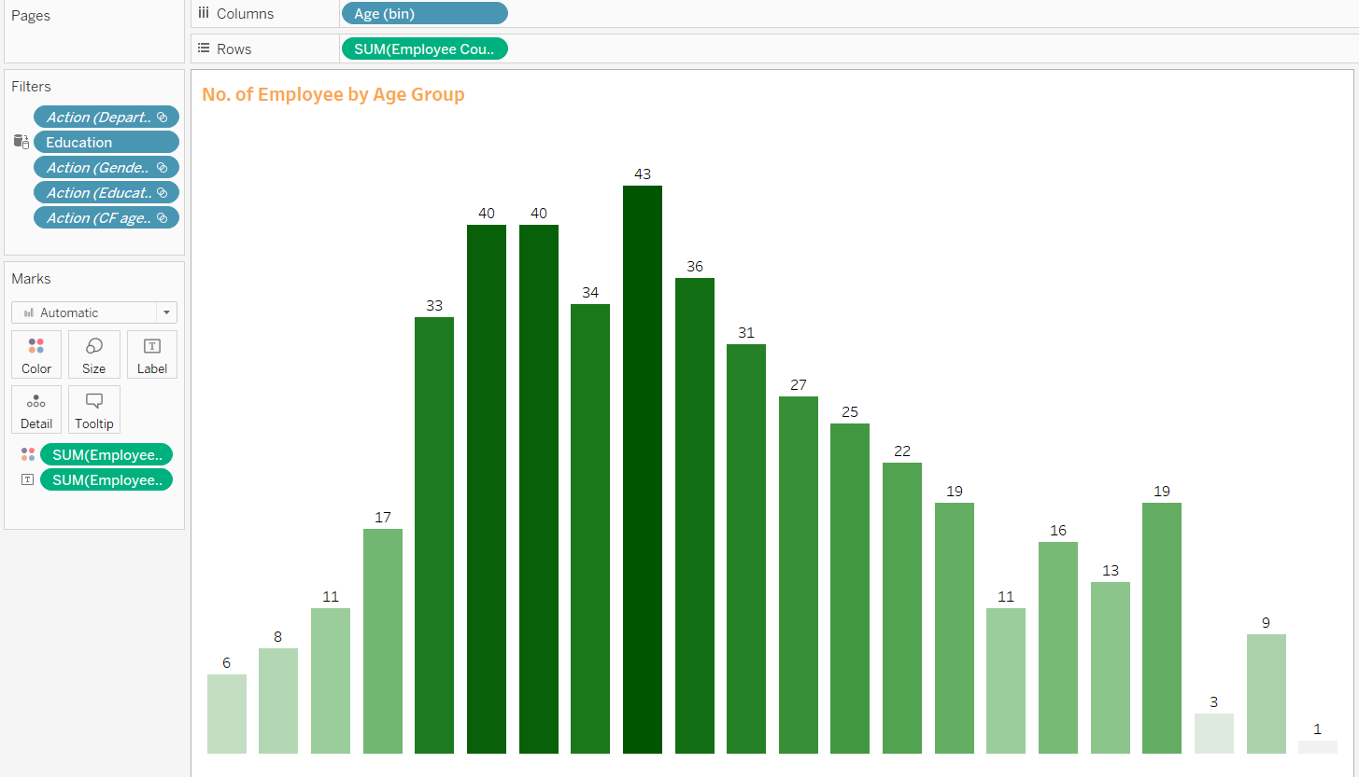

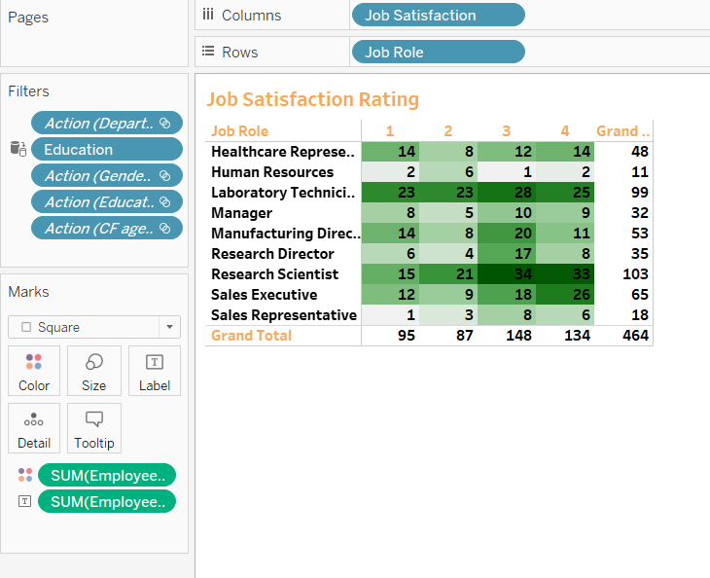

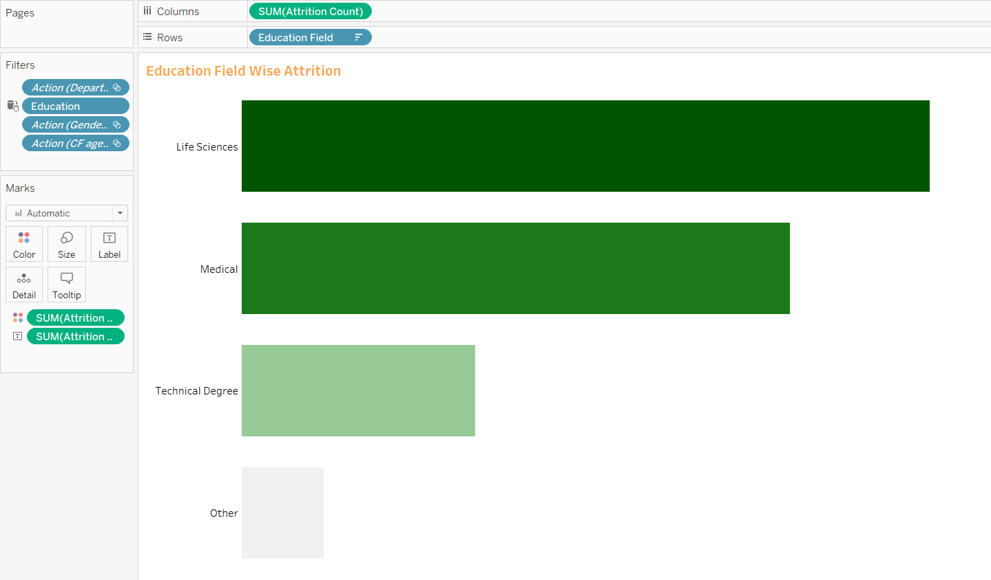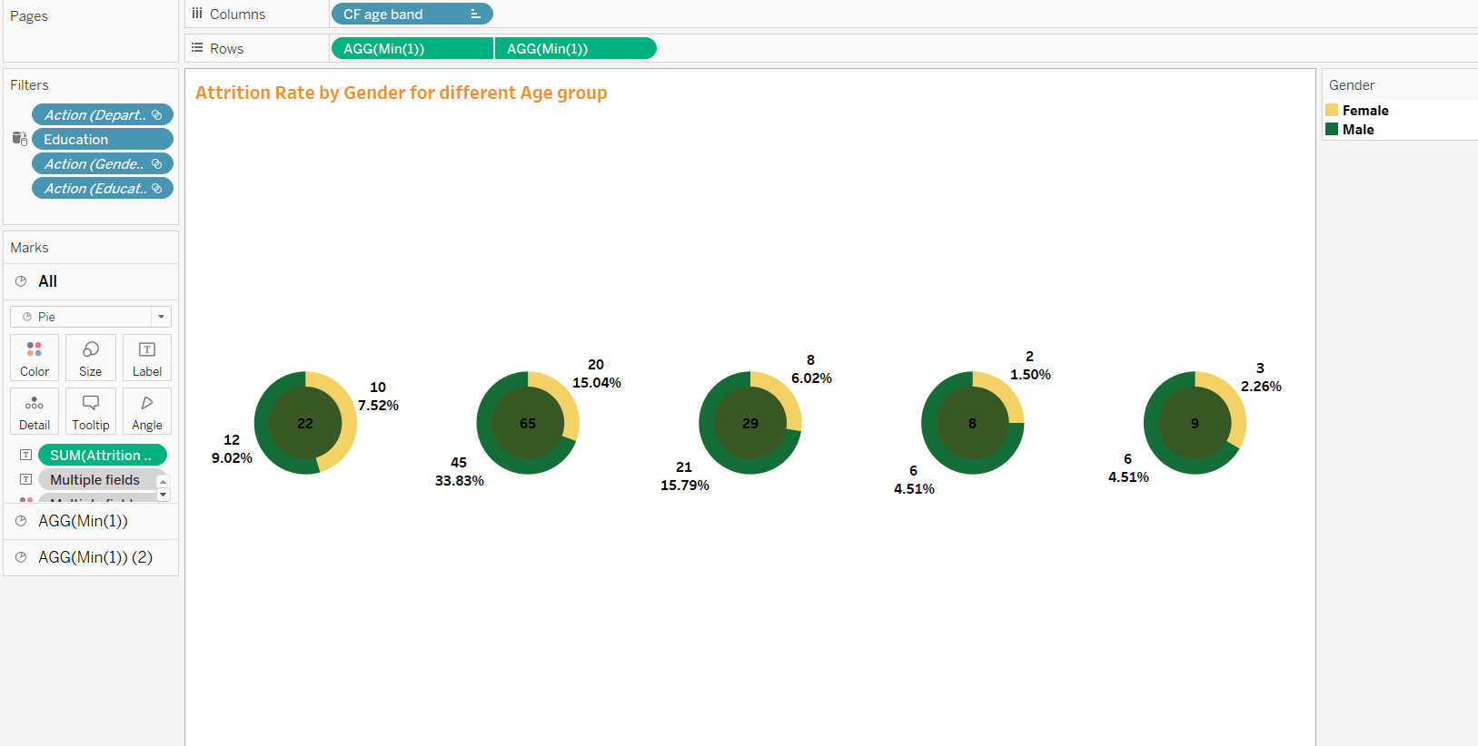

**After creating dashboard lets do sql check and make sql test report on this dashboard.**

**SQL queries:-**

**TESTING TABLEAU REPORT IN SQL**

**-----*******************----Creating Table ------\*\*\*\*\*\*\*\*\*\*\*\*\*\*\*\*\*\*\***

**create table hrdata**

**(**

**emp_no int8 PRIMARY KEY,**

**gender varchar(50) NOT NULL,**

**marital_status varchar(50),**

**age_band varchar(50),**

**age int8,**

**department varchar(50),**

**education varchar(50),**

**education_field varchar(50),**

**job_role varchar(50),**

**business_travel varchar(50),**

**employee_count int8,**

**attrition varchar(50),**

**attrition_label varchar(50),**

**job_satisfaction int8,**

**active_employee int8**

**)**

**----***********************----Importing Data------\*\*\*\*\*\*\*\*\*\*\*\*\*\*\*\*\*\*\*\*\***

**COPY hrdata from 'C:\Users\lenovo\Downloads\hrdata.csv' DELIMITER ',' CSV HEADER;**

**----********************----- Employee Count-------\*\*\*\*\*\*\*\*\*\*\*\*\*\*\*\*\*\*\*\*\*\***

**Select sum(employee_count) from hrdata**

**----*** With Filter**

**--* Education**

**select sum(employee_count) from hrdata**

**where education = 'High School'**

**---* Department Filter**

**select sum(employee_count) from hrdata**

**where department = ‘R&D’**

**---* Education field**

**Select sum(employee_count) as employee_count from hrdata**

**where education_field = ‘Medical’**

**--***********************----- Attrition count----- \*\*\*\*\*\*\*\*\*\*\*\*\*\*\*\*\*\*\*\*\***

**Select count(attrition) from hrdata**

**where attrition = 'Yes'**

**--* With filter**

**Select count(attrition) from hrdata**

**where attrition = 'Yes' and education = 'Doctoral Degree'**

**---*********************-----Attrition Rate-----\*\*\*\*\*\*\*\*\*\*\*\*\*\*\*\*\*\*\*\*\*\*\*\*\*\***

**--** Without filter**

**Select round(((select count(attrition) from hrdata where attrition = 'Yes')/sum(employee_count))*100,0)as Attrition_Rate from hrdata**

**--** With filter**

**Select round(((select count(attrition) from hrdata where attrition = 'Yes' and department = 'Sales')/sum(employee_count))*100,0)as Attrition_Rate from hrdata**

**where department = 'Sales'**

**----**********************-----Active Employees------\*\*\*\*\*\*\*\*\*\*\*\*\*\*\*\*\*\*\*\*\***

**Select sum(employee_count)-(select count(attrition) from hrdata where attrition = 'Yes') as Active_Employees from hrdata**

**---* With Filter**

**Select sum(employee_count)-(select count(attrition) from hrdata where attrition = 'Yes'and gender = 'Male') as Active_Employees from hrdata**

**where gender = 'Male'**

**----************************-----Average Age -------\*\*\*\*\*\*\*\*\*\*\*\*\*\*\*\*\*\*\*\*\*\***

**Select round(avg(age),0) as Average_age from hrdata**

**--** With Filter**

**Select round(avg(age),0) as Average_age from hrdata**

**where gender = 'Female'**

**--**************------------ Attrition By Gender —-----\*\*\*\*\*\*\*\*\*\*\*\*\*\*\*\*\*\*\***

**Select gender,count(attrition ) from hrdata where attrition = 'Yes'**

**group by gender**

**order by count(attrition) DESC**

**---** With filter**

**--* Education**

**Select gender,count(attrition ) from hrdata where attrition = 'Yes' and education = 'High School'**

**group by gender**

**order by count(attrition) DESC**

**—-**************------- Department Wise Attrition —------\*\*\*\*\*\*\*\*\*\*\*\*\*\*\*\*\***

**select department,count(attrition)as Attrition_count,**

**round((cast(count(attrition)as numeric) /(select count(attrition) from hrdata where attrition = 'Yes') )*100,2)as Attrition_Percentage_Department_Wise**

**from hrdata**

**where attrition = 'Yes'**

**group by department**

**order by count(attrition)**

**----* With Filter**

**--*Gender**

**select department,count(attrition)as Attrition_count,**

**round((cast(count(attrition)as numeric) /(select count(attrition) from hrdata where attrition = 'Yes' and Gender = 'Female') )*100,2)as Attrition_Percentage_Department_Wise**

**from hrdata**

**where attrition = 'Yes' and gender = 'Female'**

**group by department**

**order by count(attrition) desc**

**---*************------- No.of Employees by Age Group —-------\*\*\*\*\*\*\*\*\*\*\*\*\***

**select age,sum(employee_count) from hrdata**

**group by age**

**order by age**

**---** With filter**

**--* department**

**select age,sum(employee_count) from hrdata**

**where department = 'R&D'**

**group by age**

**order by age**

**-------***********-------Education Wise Attrition—------- \*\*\*\*\*\*\*\*\*\*\*\*\*\*\***

**select education_field, count(attrition) from hrdata**

**where attrition = 'Yes'**

**group by education_field**

**order by count(attrition) desc**

**--** With Filter**

**--*department**

**select education_field, count(attrition) from hrdata**

**where attrition = 'Yes' and department = 'Sales'**

**group by education_field**

**order by count(attrition) desc**

**----****-----Attrition Rate by Gender for different Age Group—----\*\*\*\*\*\*\*\***

**select age_band,gender,count(attrition),**

**round((cast(count(attrition) as numeric)/(select count(attrition) from hrdata where attrition = 'Yes'))*100,2) as percentage_attrition_**

**from hrdata**

**where attrition = 'Yes'**

**group by age_band,gender**

**order by count(attrition) desc**

**----*************----------JOB Satisfaction Rating—------------\*\*\*\*\*\*\*\*\*\*\***

**CREATE EXTENSION IF NOT EXISTS tablefunc;**

**Select \***

**from crosstab(**

**'SElECT job_role,job_satisfaction,sum(employee_count)**

**From hrdata**

**group by job_role , job_satisfaction**

**order by job_role,job_satisfaction')**

**as ct(job_role varchar(50),one numeric, two numeric,three numeric,four numeric)**

**order by job_role**

**SQL Test document in this Tableau Dashboard:-**

**Test Document**

| **Client Name** | XYZ_Analytics |
| --- | --- |
| **Report Name** | HR Analytics Dashboard |
| **Developer Name** | —------ |
| **Tester Name** | —--------- |
| **Project Manager** | —------- |
| **Development Tool** | **Tableau Desktop** |

| **Test No.** | **Sheet Name** | **Query** | **Test Result** | **QA Remark** |
| --- | --- | --- | --- | --- |
| 1 | KPI- Employee Count | select sum(employee_count) as Employee_Count from hrdata; | Pass | Exact match |
| 2 | KPI- Attrition Count | select count(attrition) from hrdata where attrition='Yes'; | Pass | Exact match |
| 3 | KPI- Attrition Rate | select  round (((select count(attrition) from hrdata where attrition='Yes')/  sum(employee_count)) * 100,0)  from hrdata; | Pass | Exact match |
| 4 | KPI- Active Employee | select sum(employee_count) - (select count(attrition) from hrdata where attrition='Yes') from hrdata; | Pass | Exact match |
| 5 | KPI- Average Age | select round(avg(age),0) from hrdata; | Pass | Exact match |
| 6 | Attrition by Gender | select gender, count(attrition) as attrition_count from hrdata  where attrition='Yes'  group by gender  order by count(attrition) desc; | Pass | Exact match |
| 7 | Department wise Attrition | select department, count(attrition), round((cast (count(attrition) as numeric) /  (select count(attrition) from hrdata where attrition= 'Yes')) * 100, 2) as pct from hrdata  where attrition='Yes'  group by department  order by count(attrition) desc; | Pass | Exact match |
| 8 | No of Employee by Age Group | SELECT age, sum(employee_count) AS employee_count FROM hrdata  GROUP BY age  order by age; | Pass | Exact match |
| 9 | Education Field wise Attrition | select education_field, count(attrition) as attrition_count from hrdata  where attrition='Yes'  group by education_field  order by count(attrition) desc; | Pass | Exact match |
| 10 | Attrition Rate by Gender for different Age group | select age_band, gender, count(attrition) as attrition,  round((cast(count(attrition) as numeric) / (select count(attrition) from hrdata where attrition = 'Yes')) * 100,2) as pct  from hrdata  where attrition = 'Yes'  group by age_band, gender  order by count(attrition) desc | Pass | Exact match |
| 11 | Job Satisfaction Rating | SELECT * FROM  crosstab('SELECT job_role, job_satisfaction, sum(employee_count)  FROM hrdata  GROUP BY job_role, job_satisfaction  ORDER BY job_role, job_satisfaction'  ) AS ct(job_role varchar(50), one numeric, two numeric, three numeric, four numeric)  ORDER BY job_role; | Pass | Exact match |

**Test Result:**

| **Total Tests** | 11 |
| --- | --- |
| **Pass** | 11 |
| **Fail** | 00 |
| **Blocked** | 00 |
| **Not Executed** | 00 |

**Power BI Dashboard:-**

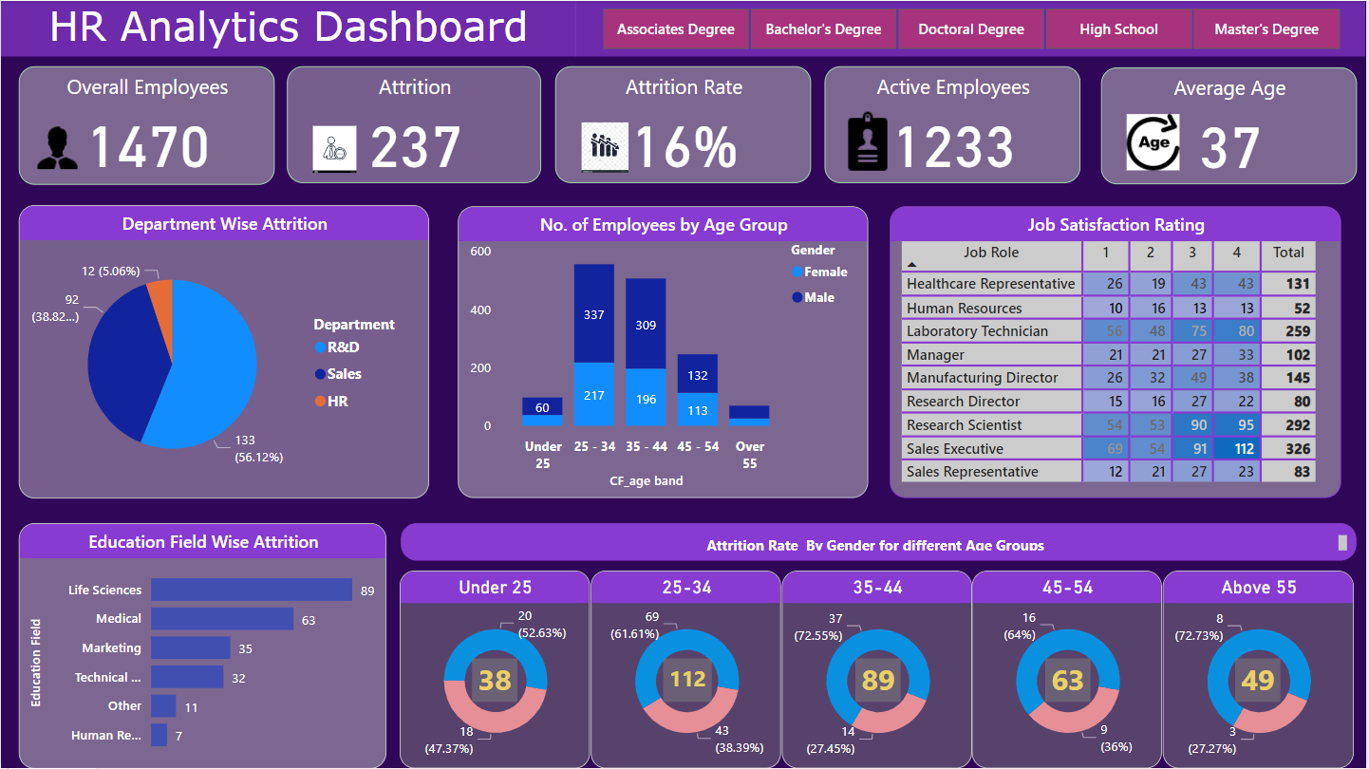

**Power BI Dashboard**

**Dashboard Summary:-** This Dashboard contain following features:

**KPIs:**

* **Employee Count:-** Total Number of employees in the organisation.
* **Attrition Count:-**  The number of employees who have left the organisation.
* **Attrition Rate:-** The percentage of employees who have left in a given period.
* **Active Employees:-** The number of employees currently employed.
* **Average Age:-** The average age of employees in the organisation.

**Charts:**

* **Department -wise Attrition:-** A pie chart displaying attrition count by department.
* **Number of Employees by Age Group:-** A stacked bar chart showing distribution of employees by age groups and also gender.
* **Job satisfaction rating:-**  A guage chart displaying job satisfaction ratings.
* **Education Field-wise attrition:-** A bar chart showing attrition count by education field.
* **Attrition Rate by Gender by Different Age groups:-** Series of Doughnut charts displaying attrition rates by gender and different age groups.

**Filters:**

**Education filter:-** Allow user to select particular education i.e. Bachelor’s Degree etc.

Glance of Power BI dashboard features/sheet:-

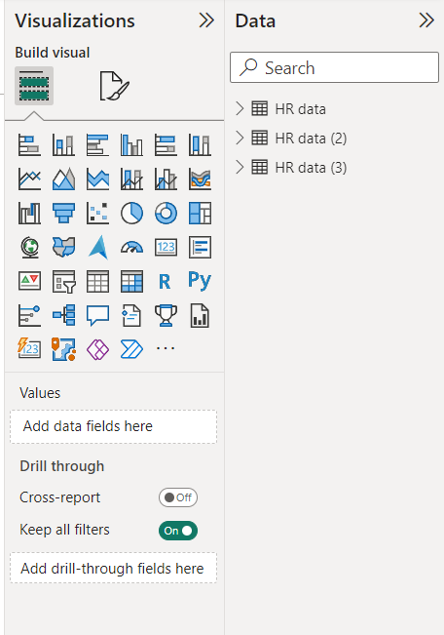

Power Bi support direct “build visual” feature so we need not to make bunch of sheets like tableau there.

Here data which we use is “HR data”.

After making dashboard Lets do SQL query check on it.

**SQL queries:-**

**TESTING POWER BI REPORT IN SQL**

**-----*******************----Creating Table ------\*\*\*\*\*\*\*\*\*\*\*\*\*\*\*\*\*\*\***

**create table hrdata**

**(**

**emp_no int8 PRIMARY KEY,**

**gender varchar(50) NOT NULL,**

**marital_status varchar(50),**

**age_band varchar(50),**

**age int8,**

**department varchar(50),**

**education varchar(50),**

**education_field varchar(50),**

**job_role varchar(50),**

**business_travel varchar(50),**

**employee_count int8,**

**attrition varchar(50),**

**attrition_label varchar(50),**

**job_satisfaction int8,**

**active_employee int8**

**)**

**----***********************----Importing Data------\*\*\*\*\*\*\*\*\*\*\*\*\*\*\*\*\*\*\*\*\***

**COPY hrdata from 'C:\Users\lenovo\Downloads\hrdata.csv' DELIMITER ',' CSV HEADER;**

**----********************----- Employee Count-------\*\*\*\*\*\*\*\*\*\*\*\*\*\*\*\*\*\*\*\*\*\***

**Select sum(employee_count) from hrdata**

**----*** With Filter**

**--* Education**

**select sum(employee_count) from hrdata**

**where education = 'High School'**

**---* Department Filter**

**select sum(employee_count) from hrdata**

**where department = ‘R&D’**

**---* Education field**

**Select sum(employee_count) as employee_count from hrdata**

**where education_field = ‘Medical’**

**--***********************----- Attrition count----- \*\*\*\*\*\*\*\*\*\*\*\*\*\*\*\*\*\*\*\*\***

**Select count(attrition) from hrdata**

**where attrition = 'Yes'**

**--* With filter**

**Select count(attrition) from hrdata**

**where attrition = 'Yes' and education = 'Doctoral Degree'**

**---*********************-----Attrition Rate-----\*\*\*\*\*\*\*\*\*\*\*\*\*\*\*\*\*\*\*\*\*\*\*\*\*\***

**--** Without filter**

**Select round(((select count(attrition) from hrdata where attrition = 'Yes')/sum(employee_count))*100,0)as Attrition_Rate from hrdata**

**--** With filter**

**Select round(((select count(attrition) from hrdata where attrition = 'Yes' and department = 'Sales')/sum(employee_count))*100,0)as Attrition_Rate from hrdata**

**where department = 'Sales'**

**----**********************-----Active Employees------\*\*\*\*\*\*\*\*\*\*\*\*\*\*\*\*\*\*\*\*\***

**Select sum(employee_count)-(select count(attrition) from hrdata where attrition = 'Yes') as Active_Employees from hrdata**

**---* With Filter**

**Select sum(employee_count)-(select count(attrition) from hrdata where attrition = 'Yes'and gender = 'Male') as Active_Employees from hrdata**

**where gender = 'Male'**

**----************************-----Average Age -------\*\*\*\*\*\*\*\*\*\*\*\*\*\*\*\*\*\*\*\*\*\***

**Select round(avg(age),0) as Average_age from hrdata**

**--** With Filter**

**Select round(avg(age),0) as Average_age from hrdata**

**where gender = 'Female'**

**--**************------------ Attrition By Gender —-----\*\*\*\*\*\*\*\*\*\*\*\*\*\*\*\*\*\*\***

**Select gender,count(attrition ) from hrdata where attrition = 'Yes'**

**group by gender**

**order by count(attrition) DESC**

**---** With filter**

**--* Education**

**Select gender,count(attrition ) from hrdata where attrition = 'Yes' and education = 'High School'**

**group by gender**

**order by count(attrition) DESC**

**—-**************------- Department Wise Attrition —------\*\*\*\*\*\*\*\*\*\*\*\*\*\*\*\*\***

**select department,count(attrition)as Attrition_count,**

**round((cast(count(attrition)as numeric) /(select count(attrition) from hrdata where attrition = 'Yes') )*100,2)as Attrition_Percentage_Department_Wise**

**from hrdata**

**where attrition = 'Yes'**

**group by department**

**order by count(attrition)**

**----* With Filter**

**--*Gender**

**select department,count(attrition)as Attrition_count,**

**round((cast(count(attrition)as numeric) /(select count(attrition) from hrdata where attrition = 'Yes' and Gender = 'Female') )*100,2)as Attrition_Percentage_Department_Wise**

**from hrdata**

**where attrition = 'Yes' and gender = 'Female'**

**group by department**

**order by count(attrition) desc**

**---*************------- No.of Employees by Age Group —-------\*\*\*\*\*\*\*\*\*\*\*\*\***

**select age,sum(employee_count) from hrdata**

**group by age**

**order by age**

**---** With filter**

**--* department**

**select age,sum(employee_count) from hrdata**

**where department = 'R&D'**

**group by age**

**order by age**

**-------***********-------Education Wise Attrition—------- \*\*\*\*\*\*\*\*\*\*\*\*\*\*\***

**select education_field, count(attrition) from hrdata**

**where attrition = 'Yes'**

**group by education_field**

**order by count(attrition) desc**

**--** With Filter**

**--*department**

**select education_field, count(attrition) from hrdata**

**where attrition = 'Yes' and department = 'Sales'**

**group by education_field**

**order by count(attrition) desc**

**----****-----Attrition Rate by Gender for different Age Group—----\*\*\*\*\*\*\*\***

**select age_band,gender,count(attrition),**

**round((cast(count(attrition) as numeric)/(select count(attrition) from hrdata where attrition = 'Yes'))*100,2) as percentage_attrition_**

**from hrdata**

**where attrition = 'Yes'**

**group by age_band,gender**

**order by count(attrition) desc**

**----*************----------JOB Satisfaction Rating—------------\*\*\*\*\*\*\*\*\*\*\***

**CREATE EXTENSION IF NOT EXISTS tablefunc;**

**Select \***

**from crosstab(**

**'SElECT job_role,job_satisfaction,sum(employee_count)**

**From hrdata**

**group by job_role , job_satisfaction**

**order by job_role,job_satisfaction')**

**as ct(job_role varchar(50),one numeric, two numeric,three numeric,four numeric)**

**order by job_role**

**SQL Test document in this Power BI Dashboard:-**

**TEST DOCUMENT**

| **Client Name** | XYZ_Analytics |
| --- | --- |
| **Report Name** | HR Analytics Dashboard |
| **Developer Name** |  |
| **Tester Name** |  |
| **Project Manager** |  |
| **Development Tool** | **Power BI** |

| **Test No.** | **Sheet Name** | **Query** | **Test Result** | **QA Remark** |
| --- | --- | --- | --- | --- |
| 1 | KPI- Employee Count | select sum(employee_count) as Employee_Count from hrdata; | Pass | Exact match |
| 2 | KPI- Attrition Count | select count(attrition) from hrdata where attrition='Yes'; | Pass | Exact match |
| 3 | KPI- Attrition Rate | select  round (((select count(attrition) from hrdata where attrition='Yes')/  sum(employee_count)) * 100,2)  from hrdata; | Pass | Exact match |
| 4 | KPI- Active Employee | select sum(hr.employee_count) - (select count(attrition) from hrdata where attrition='Yes') from hrdata; | Pass | Exact match |
| 5 | KPI- Average Age | select round(avg(age),0) from hrdata; | Pass | Exact match |
| 6 | Attrition by Gender | select gender, count(attrition) as attrition_count from hrdata  where attrition='Yes'  group by gender  order by count(attrition) desc; | Pass | Exact match |
| 7 | Department wise Attrition | select department, count(attrition), round((cast (count(attrition) as numeric) /  (select count(attrition) from hrdata where attrition= 'Yes')) * 100, 2) as pct from hrdata  where attrition='Yes'  group by department  order by count(attrition) desc; | Pass | Exact match |
| 8 | No of Employee by Age Group | select age_band, gender, sum(employee_count) from hrdata  group by age_band, gender  order by age_band, gender desc | Pass | Exact match |
| 9 | Education Field wise Attrition | select education_field, count(attrition) as attrition_count from hrdata  where attrition='Yes'  group by education_field  order by count(attrition) desc; | Pass | Exact match |
| 10 | Attrition Rate by Gender for different Age group | select age_band, gender, count(attrition) as attrition,  round((cast(count(attrition) as numeric) / (select count(attrition) from hrdata where attrition = 'Yes')) * 100,2) as pct  from hrdata  where attrition = 'Yes'  group by age_band, gender  order by age_band desc; | Pass | Exact match |
| 11 | Job Satisfaction Rating | SELECT * FROM  crosstab('SELECT job_role, job_satisfaction, sum(employee_count)  FROM hrdata  GROUP BY job_role, job_satisfaction  ORDER BY job_role, job_satisfaction'  ) AS ct(job_role varchar(50), one numeric, two numeric, three numeric, four numeric)  ORDER BY job_role; | Pass | Exact match |

**Test Result:**

| **Total Tests** | 11 |
| --- | --- |
| **Pass** | 11 |
| **Fail** | 00 |
| **Blocked** | 00 |
| **Not Executed** | 00 |

—--------------------------------------------------------**********************--------------------------------------------